Jeff Hildebrandt
CAP 6675 – Complex Adaptive Systems
Fall 2017
Homework 1

2.1 Part 1

- The neighborhood I chose consists of the inner 8 cells (inner-neighbors) around a cell as well as the outer 16 cells (outer-neighbors) surrounding a cell. If the living cells in the outer-neighbors are larger than the living cells inner-neighbors then the cell dies, otherwise a new cell is created in the neighborhood 5 cells up. These rules are to simulate if every town wanted to prevent overpopulation by giving their newborns to their adjacent town. This results in every town having to kill off some of their population to make room for all the newborns. It creates an orderly system where there's never more than 8 living cells in a single neighborhood.

- There are static objects in the system, but they depend on the entire system of living cells being being horizontal bars with width of either 1 or 2. Under these conditions the neighborhoods are always creating and killing cells in the same locations.
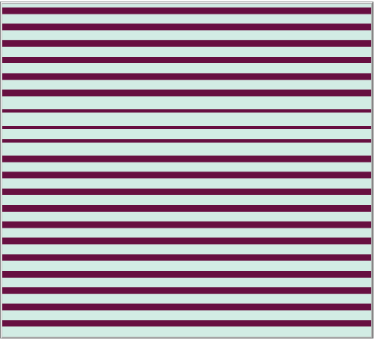
- There are periodic objects in the system. They exist when there are two rows that both aren't horizontal bars. In this state the rows that aren't horizontal bars have one neighborhood that isn't in equilibrium. That one row periodically appears and moves to the right.

- There weren't any moving objects in the system. The reason I believe this is because once the potential moving object moves into a different neighborhood, that neighborhood's outer-neighborhood becomes too populated and the cells die.
  - 2.2 Part 2

- The system I created consists of three colors, moving cells (pink), non-moving cells (black), dead cells (light blue), and permanent directional cells (blue). The permanent directional cells are given a direction on creation either up, down, left or right. When a non-moving cell is within 8 cells of a permanent directional cell and is not obstructed by another non-moving cell or by the permanent directional cell itself, then the non-moving cell turns into a moving cell and will continue to move in the direction that the permanent directional cell tells it until it runs into a non-moving cell or another permanent directional cell. The movement is simulated by the non-moving cell killing itself then creating a new moving cell in the direction it was instructed. When the density percentage of the permanent directional cells is high ( around 70%) and the initial density of living pixels is low (around 20%) then the system has a large number of endlessly moving cells of varying lengths. I wanted to create a system that simulates success based on birth location.

- Yes, by design there are static objects in the system. Any cell that is outside of the area of a permanent directional cell will be static and any cell that's right next to a permanent directional cell opposite of the direction it is instructing will be static. Note: for the diagram below the black cells represents the static objects.


- Yes, there are periodic objects in the system. The periodic objects are any moving cells that exist between two permanent directional cells with opposing directions and nothing in between the two. For instance if a permanent directional cell is instructing right and is to the left of a moving cell and a permanent directional cell is instructing left and is to the right of a moving cell with at least 2 dead cells in-between, then the moving cell will move pack and fourth endlessly. Note: for the diagram below the periodic object is the left blue cell, the pink cell, and the right blue cell. The pink cell will endlessly go back and forth between them.


- Yes, there are moving objects in the system. The moving objects only occur when a moving cell is is not obstructed by any living cells while moving across the screen. Note: This example is a directional cell with the up direction and two moving cells to its right and left.

